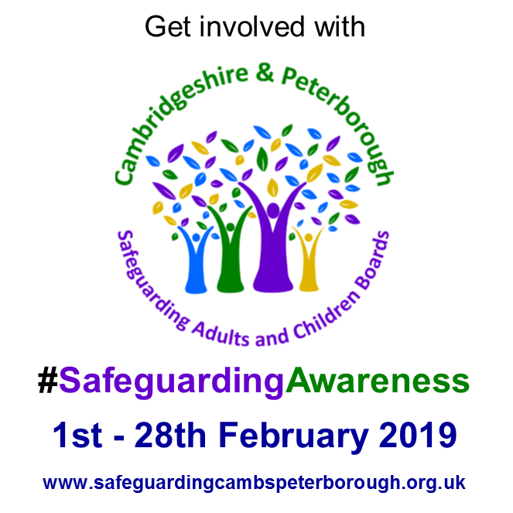

Campaign Media Pack

Table of contents
Communications leads 2
Campaign summary 3
Aims 3
Objectives 4
Audiences 4
Barriers to reporting 4
Campaign toolkit 4
Key messaging 4
Generic 4
Children 5
Adults 6
Hashtags to be used throughout the campaign where appropriate/relevant: 6
Evaluation 7
Key dates 7
Tactical plan 8
Social media assets 12
Resources 20
Banners 20
Leaflets and Posters 20

Communications leads
Safeguarding board: Jody Watts
Cambridgeshire Police: Lauren Alexander
Peterborough City Council: Pep Cipriano
Cambridgeshire County Council: Joanne Dickson
NHS Clinical Commissioning Group: Sonia Nicholls
Cross Keys Homes: Katie Taylor
Healthwatch: Angie Ridley

Campaign summary
Following on from the success of the partnership Safeguarding Awareness Month which took place in March 2018, the Cambridgeshire and Peterborough Safeguarding Children and Adults Board is now starting work to plan the campaign for 2019 which will take place in February. Once again the awareness month will involve both child and adult safeguarding themes.
The last campaign did a lot to raise awareness of safeguarding amongst professionals therefore it has been agreed by the delivery group that a natural follow on from this would be a campaign to raise awareness to the general public. This will be broken down into four themes, to be delivered as week-long awareness campaigns.
- What is meant by ‘safeguarding’
- What/who is the local safeguarding children and adults board
- Signs of abuse and how to make a referral – children
- Signs of abuse and how to make a referral – adults
Safeguarding is about keeping children, and adults who are at risk, safe from abuse and neglect, and acting quickly when abuse has been identified.
Everyone is different but some of the behavioural signs of adult neglect can include: becoming quiet and withdrawn; being upset or angry for no obvious reason; looking unkempt, dirty or thinner than usual; sudden changes in character such as appearing helpless, depressed or tearful; physical signs such as bruises, wounds, fractures or other untreated injuries; the same injuries happening more than once; not wanting to be left by themselves or along with particular people; being unusually light-hearted and insisting there's nothing wrong.
For a child behavioural signs of neglect can include: poor appearance and hygiene - they may be smelly or dirty, have unwashed clothes or seem hungry; have health or development problems - such as untreated or repeated injuries, poor muscle tone, thin or swollen stomach, tiredness or faltering weight or growth; housing and family issues - living in an unsuitable home, being left along for a long time, taking on the role of carer for other family members.

Aims
Through a targeted communications and engagement plan raise awareness and understanding of the risks faced by adults with care and support needs and children.
Raise awareness of the safeguarding of adults by working with communities and promoting the work of the board.
Effectively communicate to communities the need to safeguard and promote the welfare of children, raising awareness of how this can be done and encouraging communities to act upon information.

Objectives
To increase awareness of the risks faced by adults with care and support needs, increasing traffic to the safeguarding adults section of the CPSACB website by 1,000% in February 2019 compared to the same period the previous year (February 2018)
To increase awareness of the risks faced by children, increasing traffic to the safeguarding children section of the CPSACB website by 1,000% in February 2019 compared to the same period the previous year (February 2018)
To have each member organisation of the board contribute to Safeguarding Awareness Month 2019 – through activity or communications

Audiences
The target audience are both professionals and members of the public including children, young people, parents, carers and residents.

Barriers to reporting
We all have a role to play in protecting children, young people and adults at risk from abuse and neglect. But right now, some people do not report their concerns because they’re not certain of the signs, don’t know where to report, or are worried about being wrong. This means that safeguarding partners could be missing out on vital information they need to keep children, young people and adults at risk safe from harm.

Campaign toolkit
This media pack contains the key messages that will run across all aspects of the awareness month campaign which will include;
- Banners for email footer and newsletters
- Social media assets (imagery and videos)
- Leaflets and posters

Key messaging

Generic
- Everyone should make a significant and meaningful contribution to safeguard others – safeguarding is #everyonesbusiness
- You can help someone by reporting concerns
- We all have a role to play in protecting children and adults from abuse and neglect by reporting our concerns but some people aren’t sure what the signs are, or are worried about being wrong – don’t let that stop you from telling someone you are worried
- If you have any concerns please report it so further abuse can be prevented. There are people who can help – please contact:
  - Adults
    - For Cambridgeshire call 0345 045 5202
    - For Peterborough call 01733 747474
    - If someone is in immediate danger call 999
  - Children
    - For Cambridgeshire call 0345 045 5203
    - For Peterborough call 01733 864180
    - If someone is in immediate danger call 999
  - If contact is made early enough it might be possible to prevent harm of a child or adult from taking place
- When you report your concerns, children or adult services will:
  - Respond professionally and sensitively and take your concerns seriously
  - Talk to the police if a crime may have been committed
  - Provide help and support, and take action to end the abuse and try to ensure that it doesn’t happen again
  - Talk to other agencies that need to be involved
  - Work to keep the child or adult safe

Children
- According to NSPCC and national research, 1 in 4 people report experiences of severe physical violence, sexual abuse or neglect in childhood
- Child abuse can be physical, sexual or emotional abuse
- Mobile technology now plays a big part in child abuse
- Don’t be afraid to report child abuse – if you suspect it, report it
- If you're worried that a child is being abused, watch out for any unusual behaviour:
  - withdrawn
  - suddenly behaves differently
  - anxious
  - clingy
  - depressed
  - aggressive
  - problems sleeping
  - eating disorders
  - wets the bed
  - soils clothes
  - takes risks
  - misses school
  - changes in eating habits
  - obsessive behaviour
  - nightmares
  - drugs
  - alcohol
  - self-harm
  - thoughts about suicide

Adults
- An adult at risk of abuse or neglect is any person aged 18 or over who is, or may be, in need of community care services by reason of mental, physical or learning disability, age or illness. They may be unable to take care of themselves or unable to protect themselves against significant harm or serious exploitation
- Abuse can happen anywhere – in a residential or nursing home, in a hospital, in the workplace, at a day centre or educational establishment, in supported housing or in the street
- Crimes and forms of abuse can include physical, psychological or emotional abuse such as anti-social behaviour, threats, financial or material abuse such as theft, fraud or exploitation, neglect such as ignoring medical or physical care needs, preventing access to services or withholding food, drink or heating, and institutional abuse in residential homes, nursing homes or hospitals when people are mistreated because of poor or inadequate care, neglect

Hashtags to be used throughout the campaign where appropriate/relevant:
- #SafeguardingAwareness (for all messaging where possible)
- #spotthesigns
- #countylines
- #neglect
- #childabuse
- #domesticabuse
- #adultabuse
- #exploitation
- #itsnotok
- #SaferInternetDay
- #CareDay19
- #StillCare
- #everyonesbusiness
- #everyonesresponsibility

Evaluation
- Number of visits to promoted web pages
- Results of Twitter polls
- Media uptake (including number of interview requests, online coverage, TV coverage)
- Social media engagement
- Number of agencies taking part in Safeguarding Awareness Month

Key dates
February 4 to 10 – Sexual Abuse and Sexual Violence Awareness Week
- You can join the conversation on social media using #itsnotok and follow @itsnotok2019. You can even add our Facebook cover and Twitter banner to your profile to show your support
- You can go to a local event and meet like-minded people
February 4 to 10 – Children’s Mental Health Week
- https://www.childrensmentalhealthweek.org.uk/about-the-week/
- This year’s theme is ‘Healthy: inside and out’
- Schools and youth groups resources pack
February 5 – Safer Internet Day
- ‘Together for a better internet’ #SID2019 #SaferInternetDay
February 7 – World Mental Health Day
February 14 – Valentine’s Day
February 15 – Care Day
- Run by Voice of Young People in Care
- #CareDay19 #stillcare
February 17 – Random Acts of Kindness Day

Tactical plan
Date | Lead agency | Message/activity | Supporting materials | Channels | Media opportunity
Pre-campaign launch
w/c 14th January | Police | Safeguarding postcard | A6 postcard | N/A | No
Friday, 25th January | County council | Campaign launch press release to local media, including list of media opportunities | N/A – imagery and videos to be made available on social media throughout the month | Email press release | Yes
Monday, 28th January | CPLSACB | Materials library to be distributed among agencies | Social media cover photos, intranet banners, email signatures | N/A | No
Thursday, 31st January | Agencies to tweak press release | Intranet article for all agencies highlighting the launch of the campaign |  | Organisations’ intranets | No
Week one – what is ‘safeguarding’?
Friday, 1st February | All agencies to use – CPLSACB to create | Online cover photos |  | Facebook, Twitter, web banners (if appropriate) | No
Friday, 1st February | CPLSACB (all agencies to post) | Twitter poll (to last three days)  Whose responsibility is it to safeguard children and adults at risk of abuse or neglect?  Professionals (police, NHS, councils, etc)  Parents, carers or guardians  Everyone  No one |  | Twitter | No
Friday, 1st February | Police/Lauren | Use the spelling of ‘safeguarding’ to explain what we mean by it https://youtu.be/L6zVl2P7ElY | Video | Facebook, Twitter, embed on websites | No
Sunday, 3rd February | Police/Lauren | Excuses imagery – ‘someone else will report it’, ‘it’s not my place’, ‘maybe I’m overthinking it’ etc. It’s everyone’s business | GIF | Facebook, Twitter | No
Thursday, 7th February | CPLSACB (all agencies to post) | Twitter poll (to last three days)  Do you know what the Cambridgeshire & Peterborough Local Safeguarding Adults and Children Boards does?  Yes  No |  | Twitter | No
Week two – what/who is the local safeguarding children and adults board?
Monday, 11th February | NHS | 1. Hate Crime, Transgender and Victim information  2. Maternity – domestic abuse and FGM  3. Children’s safeguarding are doing criminal exploitation, vulnerabilities and cuckooing.  County Lines and gangs | Safeguarding postcard | Events/stands at Peterborough City Hospital to run all week  Facebook and Twitter messaging to promote this | Yes (?)
Tuesday, 12th February | Police | Safeguarding mnemonic (what is the CPLSACB?) | Mnemonic image | Facebook and Twitter | No
Week three – signs of abuse and how to make a referral (children)
Friday, 15th February | CPLSACB (all agencies to post) | Twitter poll (to last three days)  Part of the role of the @cplscb is to carry out serious case reviews relating to children suffering serious injury or death. What percentage of these reviews do you think involve a child being neglected?  40%  50%  60%  70% |  | Twitter | No
Sunday, 17th February | Police | Police – every child deserves a happy childhood video https://www.youtube.com/watch?v=kfrrd7tJLIc #RandomActsofKindnessDay | Video | Facebook, Twitter | No
Monday, 18th February | CPLSACB (all agencies to post) | RT of Twitter poll from Friday with correct answer.  Did you get the answer right on Friday? A shocking 60% of our serious case reviews for children involve neglect. If you’re concerned about the welfare of a child, please speak up. More information can be found here http://www.safeguardingcambspeterborough.org.uk/children-board/ |  | Twitter | No
Tuesday, 19th February | CPLSACB (all agencies to post) | Part of the role of the @cplscb is to carry out safeguarding adult reviews when an adult dies, or suffers significant harm as a result of abuse or neglect, whether known or suspected What is aim of a safeguarding adults review?  - to determine what agencies and individuals could have done differently that could have prevented harm or a death from taking place  - to apportion blame. |  | Twitter | No
Week four – signs of abuse and how to make a referral (adults)
Friday, 22nd February | CPLSACB (all agencies to post) | Twitter poll (to last three days)  Whose responsibility is it to safeguard children and adults at risk of abuse or neglect?  Professionals (police, NHS, councils, etc)  Parents, carers or guardians  Everyone  No one |  | Twitter | No
Sunday, 24th February | Police | Police – vulnerable adults video https://www.youtube.com/watch?v=L2kfVRs06Us | Video | Facebook, Twitter | No
Thursday, 28th February | CPLSACB (all agencies to post) | Twitter poll (to last three days)  Do you know what the Cambridgeshire & Peterborough Local Safeguarding Adults and Children Boards does?  Yes  No |  | Twitter | No

Social media assets

Asset | Twitter | Facebook
Week one – what is safeguarding?
What is safeguarding? - https://youtu.be/L6zVl2P7ElY Youtube Video | Today is the start of the @cplscb #safeguardingawareness campaign. Visit www.safeguardingcambspeterborough.org.uk for more information. https://youtu.be/L6zVl2P7ElY | The Safeguarding awareness campaign aims to make Safeguarding everyone’s responsibility Visit www.safeguardingcambspeterborough.org.uk for more information #safeguardingawareness #everyonesbusiness https://youtu.be/L6zVl2P7ElY
 | Positive prevention and early intervention is seen as key to tackling abuse and neglect. #safeguardingawareness. Visit www.safeguardingcambspeterborough.org.uk for more information. | Positive prevention and early intervention is seen as key to tackling abuse and neglect. #safeguardingawareness. Visit www.safeguardingcambspeterborough.org.uk for more information.
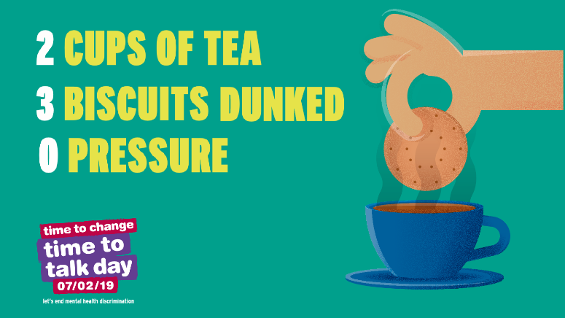 | Safeguarding is everyone’s responsibility. If you have concerns, take the time to talk to someone #safeguardingawareness #everyonesbusiness @cplscb for information and advice visit https://www.time-to-change.org.uk/ | Safeguarding is everyone’s responsibility. If you have concerns, take the time to talk to someone #safeguardingawareness #everyonesbusiness @cplscb for information and advice visit https://www.time-to-change.org.uk/
 | Because of the complex nature of the subject, often abuse and neglect go unnoticed and undetected. You can be the eyes and ears out in your community #safeguardingawareness Visit www.safeguardingcambspeterborough.org.uk for more information #everyonesbusiness @cplscb | Because of the complex nature of the subject, often abuse and neglect go unnoticed and undetected. You can be the eyes and ears to look out for signs #safeguardingawareness. Visit www.safeguardingcambspeterborough.org.uk for more information
 | Do your children use social media? As part of #SaferInternetDay2019 here’s some tips for parents and carers on how to keep children safe online http://ow.ly/F3WO30j4RPH #SafeguardingAwareness #SID2019 #SaferInternetDay | Do your children use social media? As part of #SaferInternetDay2019 here’s some tips for parents and carers on how to keep children safe online http://ow.ly/F3WO30j4RPH #SafeguardingAwareness #SID2019 #SaferInternetDay
Excuses gif | We all have a role to play in protecting children, young people and adults at risk from abuse and neglect. But right now, some people do not report their concerns because they’re not certain of the signs, don’t know where to report, or are worried about being wrong. Help us to help those in need of our support and speak up about abuse #safeguardingawareness #everyonesresponsibility | We all have a role to play in protecting children, young people and adults at risk from abuse and neglect. But right now, some people do not report their concerns because they’re not certain of the signs, don’t know where to report, or are worried about being wrong. Help us to help those in need of our support and speak up about abuse #safeguardingawareness #everyonesresponsibility
Think before you send – He said he loved me Cambs Police Youtube video https://www.youtube.com/watch?v=ylqj1DHlE_Q&t=71s | Think before you send #safeguardingawareness #saferinternetday2019  https://www.youtube.com/watch?v=ylqj1DHlE_Q&t=71s | Think before you send #safeguardingawareness #saferinternetday2019  https://www.youtube.com/watch?v=ylqj1DHlE_Q&t=71s
 | Do you know it's illegal to receive/share an image of a child under 16? Talk to children about the risks of #sexting http://ow.ly/1dXL30dxbnK #safeguardingawareness #saferinternetday2019 | Do you know it's illegal to receive/share an image of a child under 16? Talk to children about the risks of #sexting http://ow.ly/1dXL30dxbnK #safeguardingawareness #saferinternetday2019
 | We’re proud to support @Place2Be’s Children’s Mental Health Week 2019 (4-10 February) and take steps to be Healthy: Inside and Out by looking after our bodies and minds together. www.ChildrensMentalHealthWeek.org.uk #ChildrensMentalHealthWeek | Check out these FREE resources and ideas to help you get involved in Childrens Mental Health Week 2019 (4-10 February).  Whether you’re someone who works with children, a parent or carer, or passionate about supporting mental health, Place2Be need your help to reach as many people as possible:  www.ChildrensMentalHealthWeek.org.uk #ChildrensMentalHealthWeek
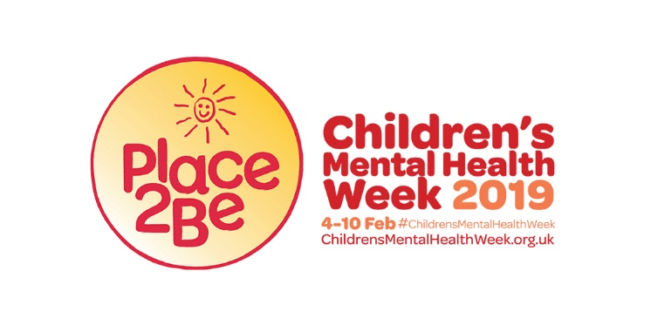 | Check out these FREE resources to help you get involved in #ChildrensMentalHealthWeek 2019 (4-10 February). Whether you're a parent, carer, work with children or are passionate about #mentalhealth, @Place2Be need your help to reach people across the country www.ChildrensMentalHealthWeek.org.uk | Check out these FREE resources to help you get involved in #ChildrensMentalHealthWeek 2019 (4-10 February). Whether you're a parent, carer, work with children or are passionate about #mentalhealth, @Place2Be need your help to reach people across the country www.ChildrensMentalHealthWeek.org.uk
Week two – what/who is the local safeguarding children and adults board?
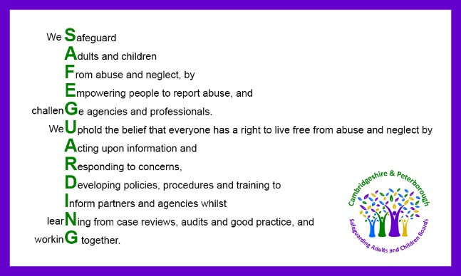 | The @CPLSCB includes @CambsCops @CambsPboroCCG, @CambsCC @PeterboroughCC, emergency services, health, education, those who work with offenders, care providers and the voluntary sector. Working in partnership to safeguard kids & adults at risk from abuse & neglect. #safeguardingawareness #workingtogether | The @CPLSCB includes @CambsCops @CambsPboroCCG, @CambsCC @PeterboroughCC, emergency services, health, education, those who work with offenders, care providers and the voluntary sector. Working in partnership to safeguard kids & adults at risk from abuse & neglect. #safeguardingawareness #workingtogether
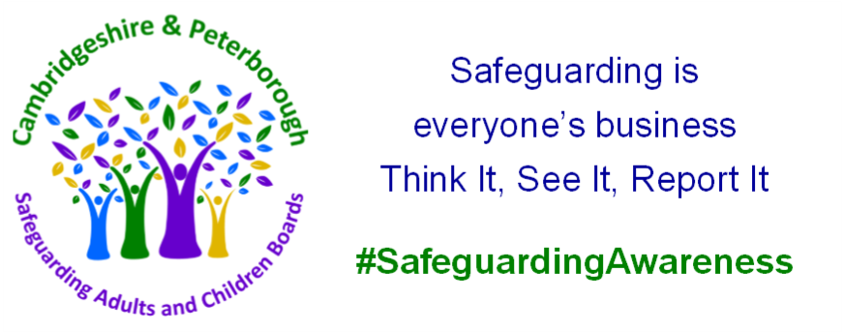 | Working together in partnership to keep children and adults at risk safe from abuse #safeguardingawareness #everyonesbusiness
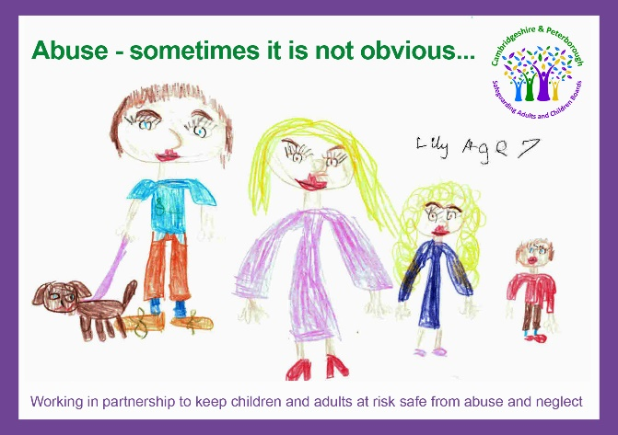 | Sometimes the signs are not obvious, but we all have a role to play in protecting children and adults at risk from abuse and neglect. #safeguardingawareness | Sometimes the signs are not obvious, but we all have a role to play in protecting children and adults at risk from abuse and neglect. #safeguardingawareness
Week three – signs of abuse and how to make a referral (children)
Signs of abuse and neglect gif | Any of these signs could indicate a child is being abused or neglected. Look out for the signs and symptoms. Visit www.safeguardingcambspeterborough.org.uk for more information #safeguardingawareness @cplscb | Any of these signs could indicate a child is being abused or neglected. Everyone can help fight against abuse and neglect by knowing how to spot the signs. Visit www.safeguardingcambspeterborough.org.uk for more information. #safeguardingawareness #everyonesbusiness
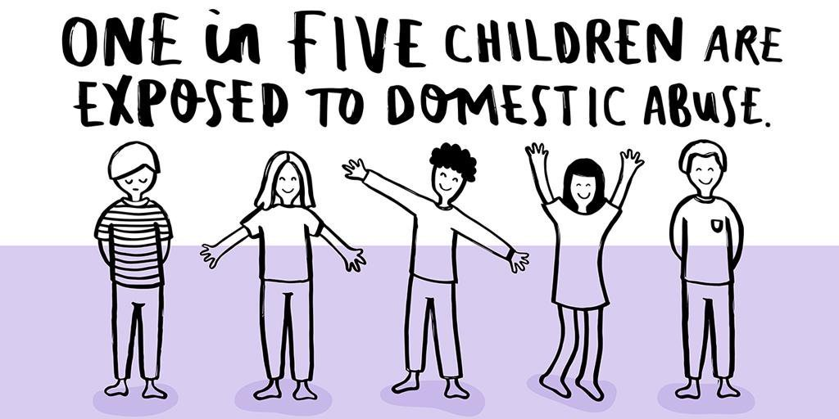 | Children who witness domestic abuse are four times more likely to become victims as adults #safeguardingawareness #domesticabuse | Children who witness domestic abuse are 4 times more likely to become victims as adults #safeguardingawareness #domesticabuse
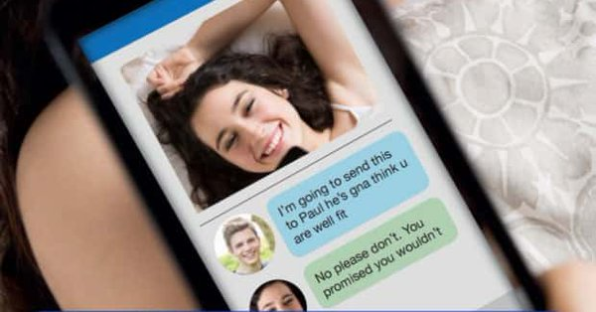 | Who's hiding behind those messages? Social media is great for communicating but for some it can be a tool to groom. Grooming of children and adults is abuse #safeguardingawareness @cplscb. For information and advice visit https://www.nspcc.org.uk/preventing-abuse/child-abuse-and-neglect/grooming/ | Who's hiding behind those messages? Social media is great for communicating but for some it can be a tool to groom. Grooming of children and adults is abuse #safeguardingawareness For information and advice visit https://www.nspcc.org.uk/preventing-abuse/child-abuse-and-neglect/grooming/
 | Sexting might seem harmless, but did you know that creating or sharing explicit images of a child is illegal? https://www.nspcc.org.uk/preventing-abuse/keeping-children-safe/sexting/ | Sexting might seem harmless, but did you know that creating or sharing explicit images of a child is illegal? https://www.nspcc.org.uk/preventing-abuse/keeping-children-safe/sexting/
https://www.youtube.com/watch?v=RdJt2g28q6k&t=20s It’s not because he loves you – Child Sexual Exploitation (Cambridgeshire police video) | Child exploitation is a form of child abuse. It is a crime that can affect girls and boys, anytime, anywhere regardless of their background or culturehttps://www.youtube.com/watch?v=RdJt2g28q6k&t=20s #safeguardingawareness #childexploitation #cse | Child exploitation is a form of child abuse. It is a crime that can affect girls and boys, anytime, anywhere regardless of their background or culturehttps://www.youtube.com/watch?v=RdJt2g28q6k&t=20s #safeguardingawareness #childexploitation #cse
https://www.youtube.com/watch?v=kfrrd7tJLIc What makes you happy? (Cambridgeshire police video) | Every child deserves a happy upbringing #safeguardingawareness | Every child deserves a happy upbringing #safeguardingawareness
https://www.youtube.com/watch?v=qmeeOPdgJow&t=4s “What if” child protection video (Cambridgeshire police video) | Do you know how many people suspect child abuse and do nothing? Don't be one of them. You may have the missing piece of the puzzle. #safeguardingawareness | Do you know how many people suspect child abuse and do nothing? Don't be one of them. You may have the missing piece of the puzzle. #safeguardingawareness
Week four – signs of abuse and how to make a referral (adults)
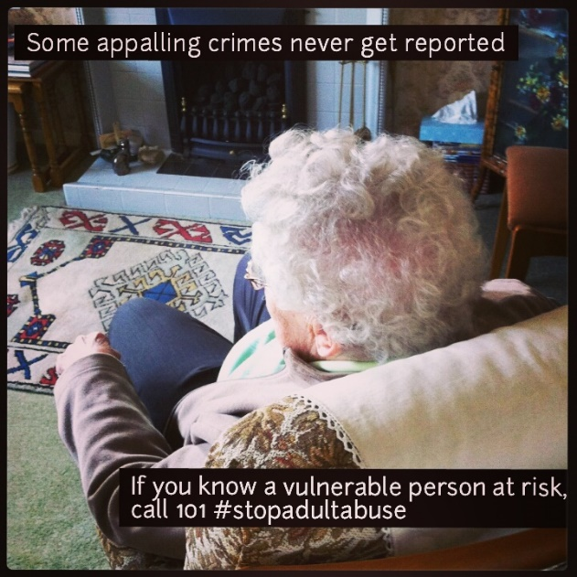 | Are you worried about someone in your community? Talk to your local social care team. Visit www.safeguardingcambspeterborough.org.uk for more information. #safeguardingawareness #everyonesbusiness @cplscb | Are you worried about someone in your community? Talk to your local social care team. #safeguardingawareness. Visit www.safeguardingcambspeterborough.org.uk for more information.
https://www.youtube.com/watch?v=L2kfVRs06Us Vulnerable adults police campaign video | Sadly there are people out there who are willing to take advantage of those who have care and support needs. If you suspect and adult is being abused, speak up and report it. #SafeguardingAwareness | Sadly there are people out there who are willing to take advantage of those who have care and support needs. If you suspect and adult is being abused, speak up and report it. #SafeguardingAwareness
 | Slavery didn’t end in 1833; it’s still happening today. Please know the signs and report any concerns. Visit www.safeguardingcambspeterborough.org.uk #safeguardingawareness #modernslavery #trafficking | Slavery didn’t end in 1833; it’s still happening today. Please know the signs and report any concerns. Visit www.safeguardingcambspeterborough.org.uk #safeguardingawareness #modernslavery #trafficking
 | If you are concerned about yourself or someone you know, help is available. #safeguardingawareness Visit www.safeguardingcambspeterborough.org.uk for more information. | If you are concerned about yourself or someone you know, help is available. #safeguardingawareness. Visit www.safeguardingcambspeterborough.org.uk for more information.
 | If you’re worried someone you know might be being abused, report it www.safeguardingcambspeterborough.org.uk #safeguardingawareness | If you are concerned about yourself or someone you know, don’t wait, report it #safeguardingawareness. Visit www.safeguardingcambspeterborough.org.uk for more information
 | Anyone with urgent concerns either about themselves or somebody else should contact @CambsCops by calling 101. Always dial 999 when there is an immediate threat to life or a crime in progress. Visit www.safeguardingcambspeterborough.org.uk for more information #safeguardingawareness | Anyone with urgent concerns either about themselves or somebody else should contact @CambsCops by calling 101. Always dial 999 when there is an immediate threat to life or a crime in progress. Visit www.safeguardingcambspeterborough.org.uk for more information #safeguardingawareness

Resources

Banners
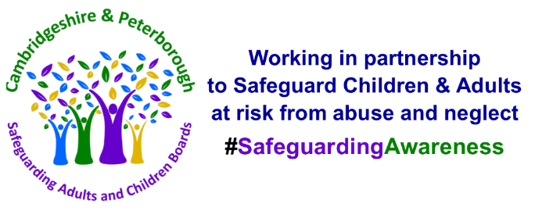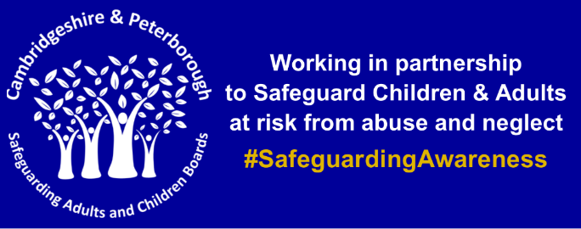
For Email footer (White PNG / Blue PNG)
For Social Media (White PNG / Blue PNG)
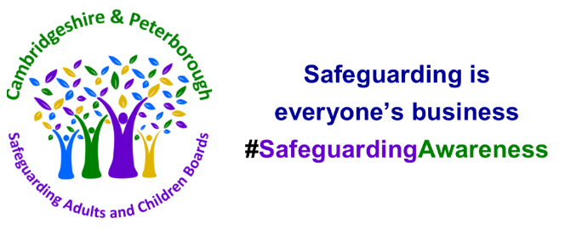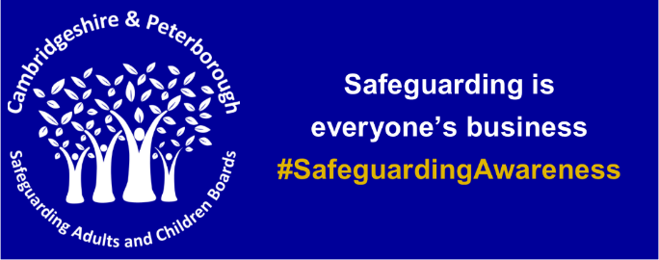
For Email footer (White PNG / Blue PNG)
For Social Media (White PNG / Blue PNG)

Leaflets and Posters
What is Abuse – Adults
What is Abuse – Children
Neglect for Parents and Carers
Child Sexual Abuse for Parents and Carers
Child Exploitation (Criminal and Sexual)
Online Safety
Self-neglect – Adults
Your Role as a Carer - Adults
Easy Read - Adults
What to do when your child goes missing

Safeguarding Wordsearch, quizzes and supporters poster that can be used to raise awareness both with members of the public and staff

Twitter Poll
1) Whose responsibility is it to safeguard children and adults with care needs?
- Professionals
- Parent/carers
- Everyones
- Nobody

2) Do you know what the Safeguarding Board do?
- Yes
- No

A Serious Case Review is undertaken where abuse or neglect is known or suspected; and either the child has died; or the child has been seriously harmed and there is cause for concern as to the way in which the authority and their partners or other relevant persons have worked together to safeguard the child.
3) What percentage of Serious Case Reviews involve Neglect?
- 40%
- 50%
- 60%
- 70%

A Safeguarding Adults Review (SAR) is undertaken when an adult dies, or suffers significant harm as a result of abuse or neglect, whether known or suspected, and there is concern that partner agencies could have worked more effectively to protect the person at risk.
4) What is aim of a safeguarding adults review?
- to determine what agencies and individuals could have done differently that could have prevented harm or a death from taking place
- to apportion blame.

5) Abuse can happen anywhere?
- True
- False

