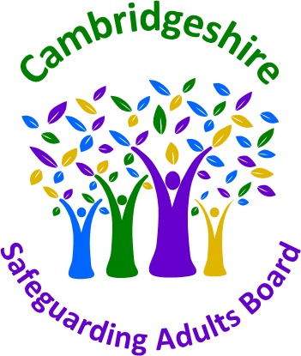 | SAR Referral Form | 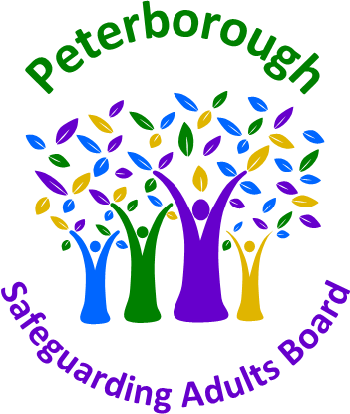
A Safeguarding Adults Review (SAR) is a process for all partner agencies to identify the lessons that can be learned from particularly complex or serious safeguarding adult cases, where an adult in vulnerable circumstances has died or been seriously injured, and abuse or neglect has been suspected. As a result of a detailed review, recommendations are made to change or improve practice and services.
The aim of the process is to learn lessons and make improvements, not to apportion blame to individual people or organisations.
A SAR is about promoting effective learning and improvement to prevent future deaths or serious harm occurring again. It relies on a spirit of openness to learning about what went well, as well as what could be improved.
Criteria for a SAR – the Safeguarding Adults Board (SAB) must arrange
a Safeguarding Adults Review when either of these criteria are met:
- An adult with care and support needs* (whether or not those needs are met by the Local Authority) in the SAB’s area has died as a result of abuse or neglect, whether known or suspected and there is concern that partner agencies could have worked together more effectively to protect the adult, or…
- An adult with care and support needs (whether or not those needs are met by the local authority) in the SAB’s area has not died, but the SAB knows or suspects the adult has experienced serious** abuse or neglect and there is concern the partner agencies could have worked together more effectively to protect the individual, or…
- The SAB has discretion to undertake a SAR in other situations where it believes that there will be value in doing so. This may be where a case can provide useful insights into the way organisations are working together to prevent and reduce abuse and neglect of adults, and can include exploring examples of good practice
* Care and support needs arise as a result of a physical or mental impairment and are focused on providing assistance with activities of daily living, maintaining independence, social interaction, enabling the individual to play a fuller part in society, protecting them in vulnerable situations, helping them to manage complex relationships and (in some circumstances) accessing a care home or other supported accommodation.
** In the context of SARs, something can be considered serious abuse or neglect where, for example, the individual would have been likely to have died but for an intervention, or has suffered permanent harm or had reduced capacity or quality of life (whether because of physical or psychological effects) as a result of the abuse or neglect.

REFERRER’S DETAILS
Agency name:
Your name: |  | Your role:
Email address:
Telephone: |  | Referral date:
NB: If you have discussed this referral with your agency’s Safeguarding Lead, please enter their details below:
Name: |  | Telephone:
Email address:
PART A - Referral for a Safeguarding Adults Review
To be completed by the referring officer
Details of adult at risk of abuse or neglect
Last name:
Forename(s):
Other names known as
Date of birth: |  |  |  | Date of death:
 |  |  |  | Date of Incident:
Gender: |  |  |  | Ethnicity:
Religion: |  |  |  | Disability:
Address:
Housing provider
GP surgery: |  |  |  | NHS number:
Care and support need details:
Details of family members and significant others
Name |  | Address | Date of Birth |  |  | Relationship to subject of referral

Please state which of the following Care Act s44 criteria does this case meet?
The adult has needs for care and support (whether or not the local authority has been meeting any of those needs) – Please specify below:
There is reasonable cause for concern about how the Safeguarding Adult Board, members of it or other persons with relevant functions worked together to safeguard the adult –
Please specify below, including in what way agencies did not work together which led to the abuse:
The adult has died and you know or suspect that the death resulted from abuse or neglect (whether or not it knew about or suspected the abuse or neglect before the adult died) – Please specify below to include what the abuse and/or neglect consisted of:
The adult is still alive and you know or suspect that the adult has experienced serious abuse or neglect – Please specify below to include what the abuse and/or neglect consisted of:

Summary of what happened
Provide a brief summary of what happened – the events and circumstances that led to this referral; include when and where the event happened, and in what context.

Please do use plain language that can be understood by those with no prior knowledge of your agency; give the meaning of any acronyms you use.
Please do not copy and paste extensive information from your agency’s records or case management systems.
Please identify the type(s) of abuse relating to this case (more than one may apply):
Click here for guidance on types and indicators of abuse
Abuse
Domestic Abuse |  | Physical Abuse |  | Discriminatory Abuse
Sexual Abuse |  | Psychological Abuse |  | Organisational Abuse
Financial or Material Abuse |  | Neglect: Long Standing |  | Neglect: Recent
Self-Neglect |  | Drugs / Solvent |  | Alcohol
Hoarding |  | Faith-Based |  | Homeless
Exploitation
Countylines |  | Trafficking |  | Sexual Exploitation
Modern Slavery |  | Radicalisation |  | Forced Marriage
Online |  | Cuckooing
Health / Medical Issues
Injury |  | Self-Harm |  | Suicide
Serious Illness |  | Life-limiting illness (natural causes) |  | Lacks capacity
Mental Illness |  | Learning Disabilities (unconfirmed) |  | Learning difficulties
Mental Illness (confirmed diagnosis) |  | Learning Disabilities (confirmed diagnosis) |  | Deprivation of Liberty Safeguards (DoLS)
Other -

Chronology of key events - Please use the chronology table below to outline any key events around the time of the incident.
PLEASE NOTE: This should only include key significant events and DOES NOT need to be a detailed chronology at this stage.
Date and Time | Event

OTHER PROCESSES & AGENCIES INVOLVED
Please provide details of any other processes you know to be underway in relation to this case, e.g. DHR, LeDeR, SI / RCA review, criminal investigation, coroner’s inquest.
Please list any other agencies or services you know to be involved in this case.
For example: social services, police, health services, fire and rescue, housing, probation services, ambulance, residential or domiciliary care, nursing homes.

Additional Information
Please add any additional information you think may be relevant and may assist decision making, including any possible learning arising from the case:

PART B - Agency Information and Involvement
You have been identified as an agency who is known to have had, or may have had contact with the person who is the subject of this SAR Referral. In light of the focus and time period of the SAR detailed above, we need make sure we have all the basic facts about the extent and nature of agency involvement with the person and any family members. Given the tight turnaround, we also want to know your agency reflections at this stage about strengths and weaknesses in practice, and the causes of those.
We are initially asking agencies to:
- Check your agency’s records to see if you have had contact with the person, their family members or close associates listed.
- Provide a brief appraisal of practice.
- Keep your agency’s submission in relation to this case separate from the case records/files.
Please return this document to the Business Unit before [insert date/time].

YOUR DETAILS
Agency name:
Name and job title of person completing the chronology
Email address:
Date of submission
Declaration of contact
Has the agency named above had contact with the adult (or family / close associates) listed in section 1 of this form?
If you have answered No, you do not need to complete further sections and should return the form to the Business Unit
If you have answered Yes, please complete the remainder of this form on the next page
Agency information for the time period under review (narrative summary)
Please summarise in a paragraph or two, how your agency has been involved with the person(s) subject of this SAR during the time period under review. Give a brief description of the nature and frequency of your involvement.
(Enter text here)
Historical context of agency information (narrative summary)
If your agency had involvement with the person before the period under review, please summarise it here.
(Enter text here)
Summary of reflections on your agency’
Please provide an overall view on what was good and where there were problems, in the agency activity reviewed, highlighting any key issues.
(Enter text here)
Please identify any areas for concern as to the way in which partners have worked together to safeguard the subject/s. and contributory factors.
(Enter text here)
What are the main wider systems issues that were at play in this case? What are the underlying causes that need to be tackled to enable improved practice in the future?
(Enter text here)
Any other issues, factors or information to note?
(Enter text here)
Please include any further relevant information that you wish to bring to the attention of the SAR Subgroup meeting or issues you would like to see discussed at this meeting.
(Enter text here)
If you have identified any initial learning for your agency while completing this analysis, please complete the table below. This will help inform the decision of the Rapid Review panel and any subsequent LCSPR should this be necessary.
Learning identified | Action taken (including timescales) |  |  | Outcome / /impact
Thank you
Once completed please email the completed form to: safeguardingboards@cambridgeshire.gov.uk

